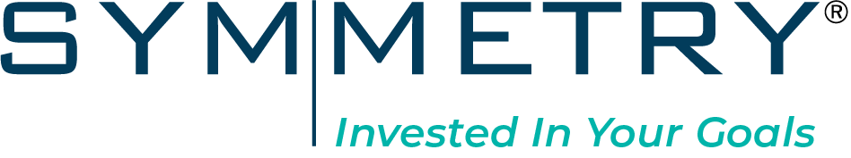

Instructions
- Please refer to your compliance department for use restrictions or additional disclosure language requirements
- If you prefer, you may delete the Symmetry logo and add your own
- Delete these instructions before forwarding.

Year-End Checklist
As We Look Forward to 2022…
It is time to review your current plan and discuss strategies that we may need to implement in the new year. I want to make sure that I fully understand the important issues that affect you and your family. Are there opportunities to implement more tax-efficient strategies? What about retirement savings or distributions? And are all your important documents up-to-date?
Please look at each of these areas below and note those that you would like to discuss further.
Family
- Discuss changes with your family that may impact your overall financial plan
- Consider potential changes to current life, disability, or long-term care insurance protection for your family
Tax Management/Tax Efficiency
- Review asset location and consider moving certain assets to a more tax-efficient account
- Review old stock positions with gains previously too high to realize
- Review old positions that may not be as tax efficient as newer investment options
- Review losses in your portfolio that may be used to offset income and future capital gains
- Discuss the feasibility of deferring or accelerating income and/or expenses
Planning
- Look at long-term plan and discuss if it is still on track
- Discuss your current cash & savings strategy
- Review current retirement contributions and retirement savings options
- Discuss whether a Roth IRA conversion is appropriate for your situation
- Discuss charitable giving and philanthropic opportunities
Investing
- Discuss the importance of your long-term investment strategy in light of current market conditions
- Discuss risk tolerance & risk capacity and if they have changed
- Review liquidity needs and cash flow requirements
Legacy
- Make sure your estate plan and will are up-to-date
- Make sure you have other important planning documents in place and updated, including Financial Power of Attorney, Health Care Power of Attorney, Living Will (Advance Health Care Directive), HIPAA Waiver, and (potentially) a Living Trust
- Make sure your loved ones know where all these documents are securely stored
- Make sure all your beneficiaries are up-to-date
Other Items
____________________________________________________________________________________________________________________________________________________________________________________________________
Once you reviewed this information, let’s schedule a phone or online meeting to discuss.
We are also happy to include your CPA or estate planning attorney in these discussions at your request.

Symmetry Partners, LLC is not affiliated with any firm mentioned in this material.
Symmetry Partners is an investment advisory firm registered with the securities and exchange commission. The firm only transacts business in states where it is properly registered, or excluded, or exempted from registration requirements. Symmetry Partners does not provide tax or legal advice, and nothing stated in this material should be inferred as providing such advice.

