Client Letter on Russia/Ukraine War

Instructions
- Please refer to your compliance department for use restrictions or additional disclosure language requirements
- If you prefer, add this to your letterhead
- Delete these instructions before forwarding.

Dear Valued Client:

Russia’s broad attack on Ukraine has many investors concerned, and we are indeed observing the immediate effects of turmoil across world markets and crude oil prices rising above $100 a barrel. What these events will mean for markets in the long-term is very hard to diagnose, but it is likely that markets will continue to experience a higher degree of volatility over the short term, as we have seen countless times before in moments of uncertainty.
It is unusual for markets to be solely driven by geopolitical events over the long-term, and historical precedent can provide some perspective (see the two charts below).

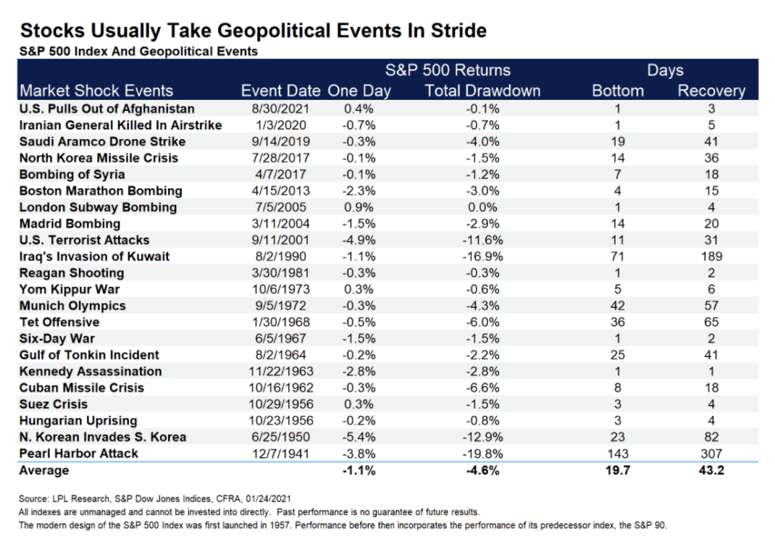

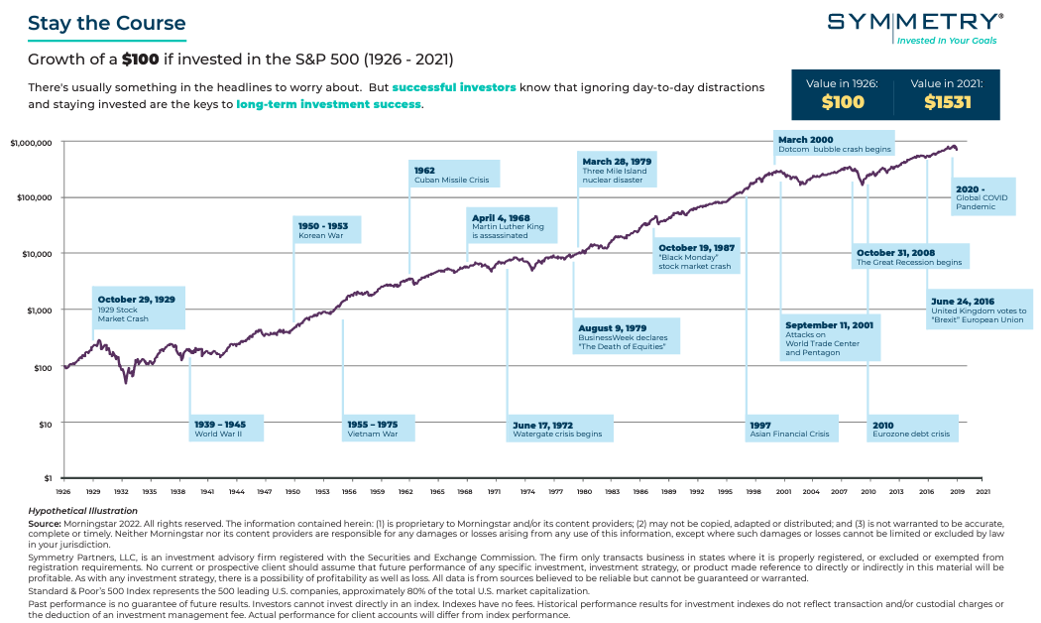

Here's the key takeaway: While the human and social costs of war are terrible, geopolitical events tend to have few lasting effects on markets and global economies. Whatever is going on in the world, markets rise and fall, and then they tend to rise again. It is simply the nature of how markets work. If you invest with a long-term, balanced and consistent approach, current events are unlikely to have a dramatic effect on your investments over the longer term.
You should be confident in knowing that we constantly monitor the domestic and international markets and watch the impacts of events to your portfolios closely. We will always work to keep you well informed. However, while we regularly monitor these market movements, we remain committed to our disciplined and diversified approach to investing for the long-term and recommend extreme caution in making any changes to portfolios based on current events.
We thank you for the opportunity to serve you.

All data is from sources believed to be reliable but cannot be guaranteed or warranted. Different types of investments involve varying degrees of risk, and there can be no assurance that the future performance of any specific investment, investment strategy, product or any non-investment related content made reference to directly or indirectly in this commentary will be profitable, equal any corresponding indicated historical performance level(s), be suitable for your portfolio or individual situation, or prove successful. Due to various factors, including changing market conditions and/or applicable laws, the content may not be reflective of current opinions or positions. Please note you should not assume that any discussion or information contained in this material serves as the receipt of, or as a substitute for, personalized investment advice. Diversification seeks to improve performance by spreading your investment dollars into various asset classes to add balance to your portfolio. Using this methodology, however, does not guarantee a profit or protection from loss in a declining market.
Symmetry Partners, LLC, is an investment advisory firm registered with the Securities and Exchange Commission. Different types of investments involve varying degrees of risk, and there can be no assurance that the future performance of any specific investment, investment strategy, product or any non-investment related content made reference to directly or indirectly in this material will be profitable, equal any corresponding indicated historical performance level(s), be suitable for your portfolio or individual situation, or prove successful. Due to various factors, including changing market conditions and/or applicable laws, the content may not be reflective of current opinions or positions. Please note the material is provided for educational and background use only. Moreover, you should not assume that any discussion or information contained in this material serves as the receipt of, or as a substitute for, personalized investment advice. Diversification seeks to improve performance by spreading your investment dollars into various asset classes to add balance to your portfolio. Using this methodology, however, does not guarantee a profit or protection from loss in a declining market. Past performance does not guarantee future results.
Index Disclosure & Definitions
Investors cannot invest directly in an index. Indexes have no fees. Historical performance results for investment indexes do not reflect the deduction of transaction and/or custodial charges or the deduction of an investment management fee, the occurrence of which would have the effect of decreasing historical performance results. Actual performance for client accounts will differ from index performance.
S&P 500 Index represents the 500 leading U.S. companies, approximately 80% of the total U.S. market capitalization.

